CLIENT COMMUNICATION AGENT SYSTEM
Phase 1 — Planning & Architecture

Step 1 — Business Requirements & Scope

Project Overview
Business Type | Retail / E-Commerce
System | Two AI agents: Broadcast Agent (bulk outbound messaging) and Client Assistant Bot (24×7 two-way client communication).
Operator | Non-technical business owner. System must require zero technical knowledge to operate.
Initial Scale | 500 clients. Architecture must scale to 5,000 without redesign.
Communication | Two-way. Clients can reply and ask questions. Client Bot is a Day 1 requirement.
Languages | English and Hindi. Auto-detected per message. All templates prepared in both languages.

Messaging Channels — Day 1
Channel | Priority | Provider | Note
WhatsApp | Primary | Gupshup | Apply for API access in Week 1. Approval takes 1–4 weeks.
Email | Secondary | SendGrid | Free tier (100/day). Supports HTML and PDF attachments.
SMS | Tertiary | Fast2SMS | Cost-effective for India. Fallback when WhatsApp unavailable.
Telegram | Quaternary | Telegram Bot API | No approval needed. Operational within hours.

Step 2 — Technology Stack

Full Stack
Layer | Technology | Role
LLM | GPT-4o + GPT-4o mini (OpenAI) | gpt-4o-mini for routine queries; gpt-4o for complex retrieval. No GPU required. ~ ₹227.70 per 1M tokens
Agent Framework | LangGraph | Stateful multi-step agent orchestration. Native OpenAI and Chroma integration.
Vector Database | Chroma DB (self-hosted) | Semantic search over broadcast history, product data, and documents.
Embeddings | text-embedding-3-small (OpenAI) | High-quality English and Hindi embeddings. ~₹18.22 per 1M tokens.
Backend | Python 3.11 + FastAPI | Async API server and webhook receiver. Native to all AI libraries.
Relational DB | PostgreSQL 15 (Docker) | Client records, broadcast logs, delivery tracking, conversation history.
Task Queue | Celery + Redis | Async bulk sending, scheduled broadcasts, automatic retries.
WhatsApp | Gupshup | WhatsApp Business API. India-based, fast approval.
Email | SendGrid | Free tier sufficient for 500 clients.
SMS | Fast2SMS | Lowest cost SMS for India.
Telegram | Telegram Bot API | Free. No approval process.
Hosting | Hetzner Cloud CX21 | 2 vCPU / 4 GB RAM / 40 GB SSD. All services on one server. ~₹500/month.
Frontend | React 18 + Tailwind CSS + Vite | Proprietor dashboard.

Messaging Providers & Costs
Channel | Provider | Est. Monthly Cost | Notes
WhatsApp | Gupshup | ₹2,000 – 3,500 (₹2,000 for setup and ₹ 0.85 per message.) pay as you go model. | Competitive India pricing, strong local support.
Email | SendGrid | Free | 100 emails/day free. Upgrade available if needed.(paid plan- ~₹1817/month for 50,000 mails).
SMS | Fast2SMS | ₹300 – 700 | Pay-per-use. Same-day API integration.
Telegram | Telegram Bot API | Free | No cost, no approval.
LLM API | OpenAI | ~₹1,650 | GPT-4o-mini for volume; GPT-4o for retrieval.
VPS | Hetzner CX21 | ~₹500 | Runs all backend services.
Domain+SSL | Namecheap + Let's Encrypt | ~₹85 | Annual domain. Free SSL via Certbot.
Total |  | ~₹5,700 / month

Step 3 — System Architecture

3.1 System Architecture Overview
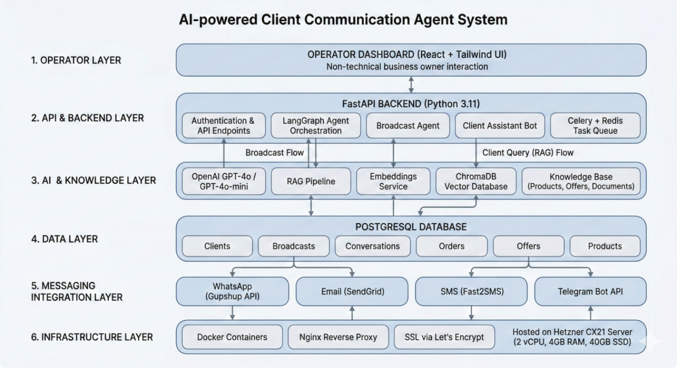

3.2 Broadcast Flow
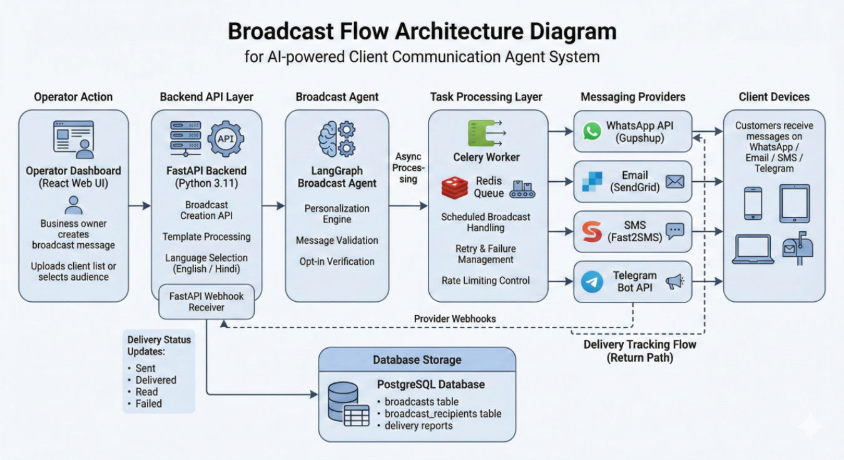

3.3 Client Query Flow — RAG Pipeline
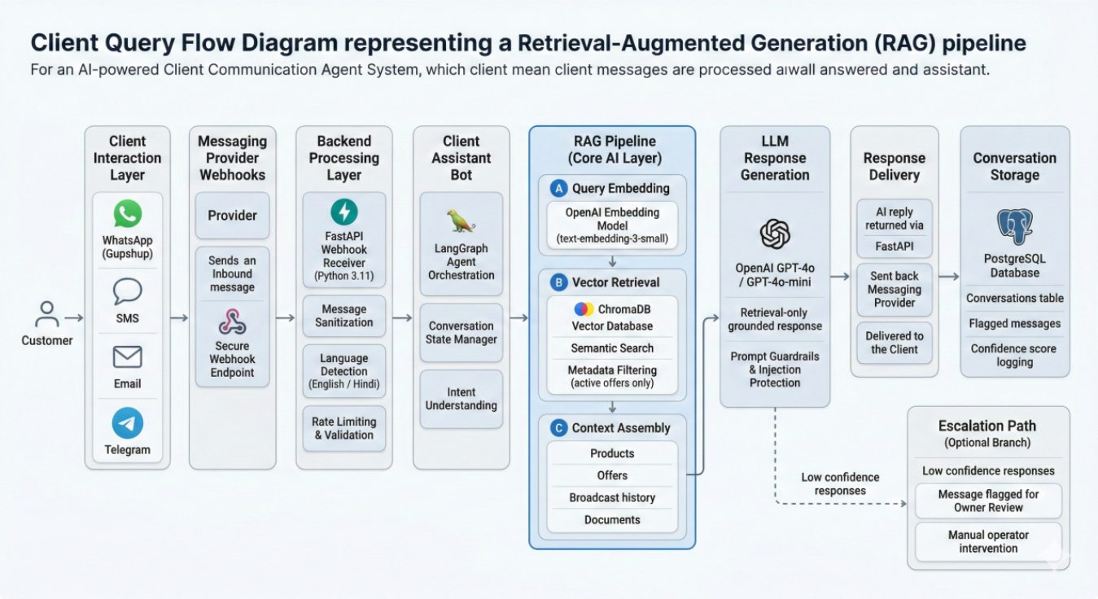

3.4 Knowledge Base — Document Ingestion
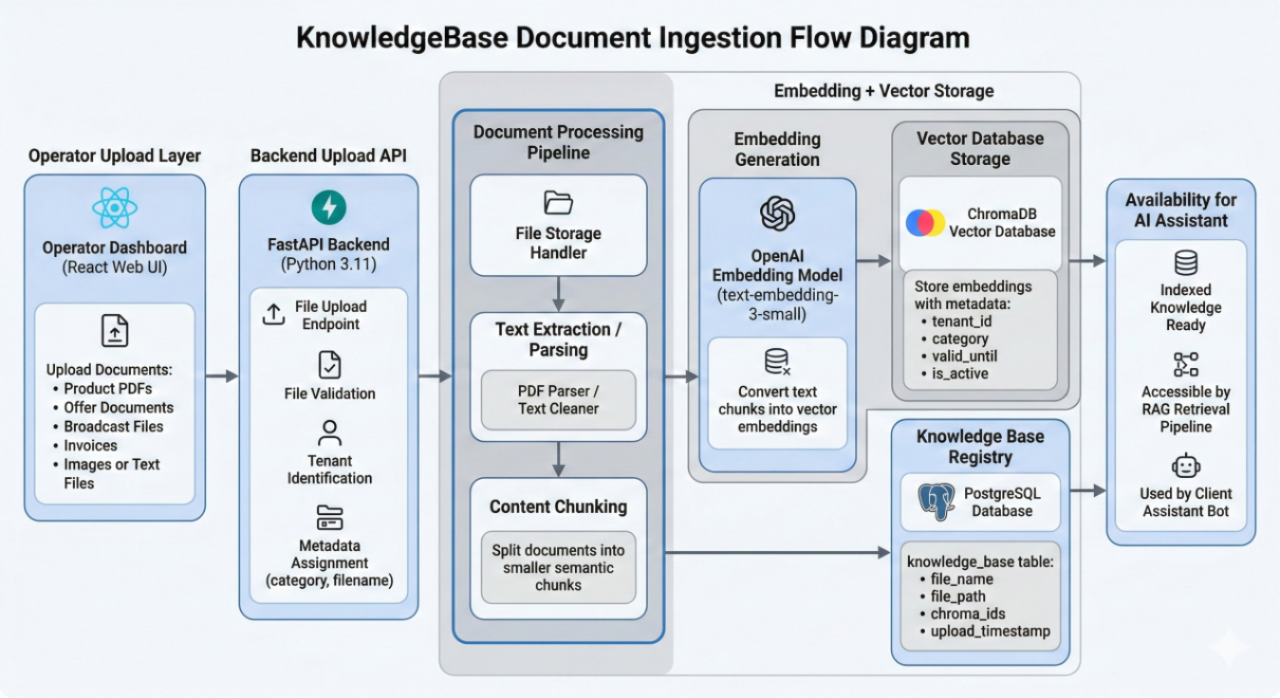

Step 4 — WhatsApp Business API Setup
Status: Complete · February 2026
WhatsApp Business API requires official provider approval before any messages can be sent. This step must be started in Week 1 as approval takes 1–4 weeks. A new dedicated phone number will be used — it must never have been registered on WhatsApp before.

4.1 Provider Comparison
Four providers were evaluated. The final provider selection should be made before Week 1 ends.

Provider | Setup Time | India Support | Est. Cost/Mo | Best For
Gupshup | 3–5 days | Excellent | ₹2,000–3,500 | Best overall for India. Largest WhatsApp BSP in India. Strong local support, competitive pricing, fast approval.
Interakt | 3–7 days | Excellent | ₹2,499+ | Good UI dashboard. Suited if the owner wants a visual WhatsApp CRM alongside the API.
Twilio | 1–3 days | Good | $50–100 | Fast setup and reliable API. Higher cost. Best if WhatsApp + SMS under one billing account is a priority.
Meta Direct | 2–4 weeks | Good | Pay per msg | No middleman cost but longest approval time and most complex setup. Not recommended for solo developers.

Recommendation | Gupshup for India-first retail. If budget allows a slightly higher cost and a built-in CRM dashboard is useful, Interakt is a strong second choice.

4.3 Message Template Requirements
WhatsApp requires all outbound broadcast messages to use pre-approved templates. Template approval typically takes 24–48 hours.

Rule | Detail
Language | Templates must be submitted in each language they will be used in. Submit both English and Hindi versions.
Category | Choose the correct category: MARKETING (offers, promotions), UTILITY (order updates, delivery), or AUTHENTICATION.
Variables | Dynamic fields use double curly brace syntax: {{1}} for first variable, {{2}} for second. Example: Hello {{1}}, your order {{2}} has been shipped.
No URLs in vars | Variable placeholders cannot contain URLs. URLs must be hardcoded in the template body.
Approval time | 24–48 hours for standard templates. Rejected templates must be resubmitted after fixing the flagged issue.
Limit | A WhatsApp Business Account starts at Tier 1: 1,000 unique recipients per day. Sufficient for 500 clients at launch.

Analytics & Safeguards

No.1 MVP Scope Revision — WhatsApp First
Item | Decision
Phase 1 channels | WhatsApp only for client broadcasts. Email used internally for owner alerts only.
Phase 2 channels | SMS (Fast2SMS) and Telegram added once Phase 1 is stable and tested.
Rationale | Multi-channel broadcast adds operational complexity, provider management overhead, and debugging surface — all high risk for a solo developer on a one-month deadline. WhatsApp covers 95%+ of the Indian retail client base.

No.2 Competitive Differentiation Matrix
The Indian WhatsApp business messaging market has established players. The differentiation below explains why this product wins in the retail SMB segment specifically.

Feature | This Product | Interakt | WATI | Zoko | Gupshup Dashboard
AI Client Assistant Bot | Yes — RAG | ✗ | ✗ | Basic | ✗
Offer expiry intelligence | ✓ | ✗ | ✗ | ✗ | ✗
Conversation memory (RAG) | ✓ | ✗ | ✗ | ✗ | ✗
Hindi language support | ✓ | ✓ | ✓ | ✓ | ✓
Broadcast personalisation | ✓ | ✓ | ✓ | ✓ | Limited
India retail pricing | Yes (₹2,999) | ✓ | ✗ | Partial | ✗
Document RAG (PDF Q&A) | ✓ | ✗ | ✗ | ✗ | ✗
Onboarding flow | ✓ | ✓ | ✓ | Partial | ✗

Differentiator | Why Competitors Cannot Easily Copy
RAG-powered assistant | Interakt, WATI, and Zoko are WhatsApp CRM tools. None have invested in document-grounded AI retrieval. Adding RAG requires ML infrastructure investment and product redesign — not a quick feature add.
Offer expiry intelligence | Sounds simple but requires Chroma metadata filtering + daily recompute jobs + bot decision logic. No competitor has this today for Indian retail.
India retail focus | WATI and Zoko price in USD and target global SMBs. This product is priced in INR, onboarded in Hindi and English, and designed specifically for local retailer workflows.
Why Gupshup will not copy | Gupshup is a messaging infrastructure provider, not a vertical SaaS company. Building a retail-specific AI layer is outside their core business model. They sell API access — this product sells outcomes.

No.3 Wireframes for the project:
https://bucolic-sopapillas-ffde8d.netlify.app/

